# Overview

**Example 53.1 Randomized Complete Blocks with Means Comparisons and Contrasts**

This example, reported by Stenstrom (1940), analyzes an experiment to investigate how snapdragons grow in various soils.

To eliminate the effect of local fertility variations, the experiment is run in blocks, with each soil type sampled

in each block. Since these data are balanced, the Type I and Type III SS are the same and are equal to the traditional ANOVA SS.

First, the standard analysis is shown, followed by an analysis that uses the SOLUTION option and includes

MEANS and CONTRAST statements. The ORDER=DATA option in the second PROC GLM statement is used so that the ordering of

coefficients in the CONTRAST statement can correspond to the ordering in the input data.

The SOLUTION option requests a display of the parameter estimates, which are produced by default only if there are no

CLASS variables. A MEANS statement is used to request a table of the means with two multiple-comparison procedures requested.

In experiments with focused treatment questions, CONTRAST statements are preferable to general means comparison methods.

The following statements produce Output 53.1.1 through Output 53.1.4.

# SAS Code

title 'Balanced Data from Randomized Complete Block';

**data** plants;

input Type $ @;

do Block = **1** to **3**;

input StemLength @;

output;

end;

datalines;

Clarion 32.7 32.3 31.5

Clinton 32.1 29.7 29.1

Knox 35.7 35.9 33.1

O'Neill 36.0 34.2 31.2

Compost 31.8 28.0 29.2

Wabash 38.2 37.8 31.9

Webster 32.5 31.1 29.7

;

**run**;

**proc** **glm**;

class Block Type / ref=first;

model StemLength = Block Type;

**run**;

**quit**;

# R Code

library(tidyverse)

library(broom)

# changed block to be a character variable so the aov()

# function treated it as a class variable.

plants <- tribble(

~type, ~block, ~StemLength,

"Clarion", "1", 32.7,

"Clarion", "2", 32.3,

"Clarion", "3", 31.5,

"Clinton", "1", 32.1,

"Clinton", "2", 29.7,

"Clinton", "3", 29.1,

"Knox", "1", 35.7,

"Knox", "2", 35.9,

"Knox", "3", 33.1,

"O'Neill", "1", 36.0,

"O'Neill", "2", 34.2,

"O'Neill", "3", 31.2,

"Compost", "1", 31.8,

"Compost", "2", 28.0,

"Compost", "3", 29.2,

"Wabash", "1", 38.2,

"Wabash", "2", 37.8,

"Wabash", "3", 31.9,

"Webster", "1", 32.5,

"Webster", "2", 31.1,

"Webster", "3", 29.7

)

summary(plants)

# Test for a significant difference in PULSE between values of SEX by

# running a one way ANOVA using the model PULSE = SEX.

aov1 <- aov(StemLength ~ type + block, data = plants) %>%

print()

# Using lm() function

lm1 <- lm(StemLength ~ type + block, data = plants) %>%

print()

summary(lm1)

summary(aov1)

# Results

## SAS

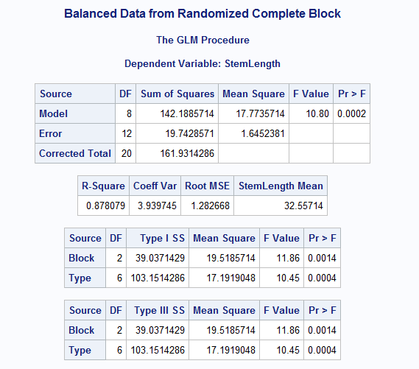

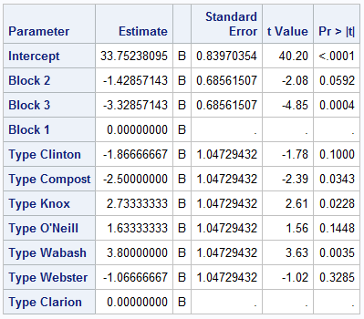

## R

